Fall 2017

Revision History

|  |  |  |  |
| --- | --- | --- | --- |
| **Date** | **Issue** | **Description** | **Author** |
|  |  |  |  |
|  |  |  |  |
|  |  |  |  |
|  |  |  |  |

Table of Contents

Potential Entity Classes 4

Classes Attributes 5

Entity Class Diagram 6

# Potential Entity Classes

|  |  |
| --- | --- |
| Class name | Brief Description |
|  |  |
|  |  |
|  |  |

# Classes Attributes

1. ***class1-name* class**

|  |  |  |
| --- | --- | --- |
| Attribute name | Type | Brief Description |
|  |  |  |
|  |  |  |
|  |  |  |
|  |  |  |
|  |  |  |

# Entity Class Diagram

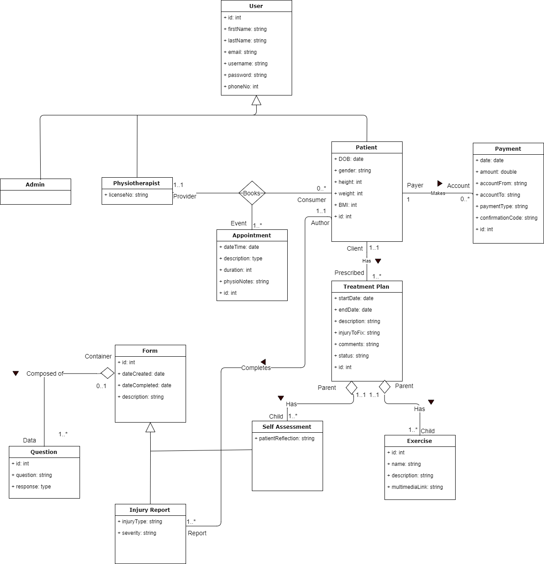

Notes:

* Where inheritance is present, the “id” is a part of the parent class (e.g. User and Form) as opposed to the child classes.
* Forms (e.g. Self-Assessment and Injury Report) consist of one to many questions, which are represented by Question entities that hold the question and the patient’s response.
* We used Aggregation for the has-a relationships. Forms have Questions, and Treatment Plans have Self Assessments and Exercises. Aggregation was used over composition, since child objects belong to a parent object, but will not be destroyed if the parent is deleted. For example, a Treatment Plan could be destroyed and the Self Assessments and Exercise can continue to persist.